Problem xy (use separate files for each problem)

10111

13 januar, 2023

install.packages("knitr")  
install.packages("MASS")  
install.packages("caret")  
install.packages("pls")  
install.packages("glmnet")  
install.packages("gam")  
install.packages("gbm")  
install.packages("randomForest")  
install.packages("ggfortify")  
install.packages("leaps")  
install.packages("pROC")  
install.packages("sfsmisc")

id <- "1kGOLsnKA0Uq2lWKlMjhAF8h71sc0WcLO" # google file ID  
d.bodyfat <- read.csv(sprintf("https://docs.google.com/uc?id=%s&export=download", id))[,-c(1)]  
set.seed(1234)  
training_set_size <- floor(0.80 * nrow(d.bodyfat))  
  
samples <- sample(1: nrow(d.bodyfat),training_set_size , replace=F)  
d.body.train <- d.bodyfat[samples,]  
d.body.test <- d.bodyfat[-samples,]

## a)

r.lm.BodyFat <- lm(BodyFat ~ . - Abdomen + poly(Abdomen, degree = 2), d.body.train)  
summary(r.lm.BodyFat)

##   
## Call:  
## lm(formula = BodyFat ~ . - Abdomen + poly(Abdomen, degree = 2),   
## data = d.body.train)  
##   
## Residuals:  
## Min 1Q Median 3Q Max   
## -11.0198 -2.9100 -0.1409 2.9595 9.3920   
##   
## Coefficients:  
## Estimate Std. Error t value Pr(>|t|)   
## (Intercept) 80.91992 21.31906 3.796 0.000199 ***  
## Age 0.06754 0.03566 1.894 0.059765 .   
## Weight -0.04196 0.06164 -0.681 0.496910   
## Height -0.06602 0.10086 -0.655 0.513560   
## Neck -0.55179 0.25729 -2.145 0.033285 *   
## Chest -0.08479 0.10716 -0.791 0.429830   
## Hip -0.09304 0.16728 -0.556 0.578760   
## Thigh 0.08789 0.15638 0.562 0.574768   
## Knee -0.10641 0.27650 -0.385 0.700799   
## Ankle 0.11223 0.23063 0.487 0.627087   
## Biceps 0.35094 0.20161 1.741 0.083391 .   
## Forearm 0.33282 0.21528 1.546 0.123807   
## Wrist -2.08478 0.58018 -3.593 0.000418 ***  
## poly(Abdomen, degree = 2)1 138.18455 15.33920 9.009 2.49e-16 ***  
## poly(Abdomen, degree = 2)2 -12.58157 5.04401 -2.494 0.013490 *   
## ---  
## Signif. codes: 0 '***' 0.001 '**' 0.01 '*' 0.05 '.' 0.1 ' ' 1  
##   
## Residual standard error: 4.234 on 186 degrees of freedom  
## Multiple R-squared: 0.7559, Adjusted R-squared: 0.7375   
## F-statistic: 41.15 on 14 and 186 DF, p-value: < 2.2e-16

The $R^{2}$ is $0.7559$. This is rather large, but we see that the Adjusted $R^{2}$ is smaller. This may indicate that the additional variables in the model is not adding value to the model.

TA.plot(r.lm.BodyFat,res= residuals(r.lm.BodyFat, type="pearson"))

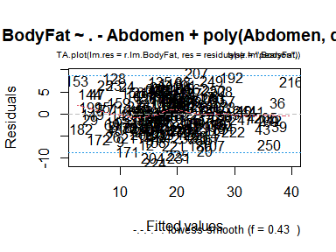

qqnorm(d.body.train$BodyFat, pch = 1, frame = FALSE)  
qqline(d.body.train$BodyFat, col = "steelblue", lwd = 2)

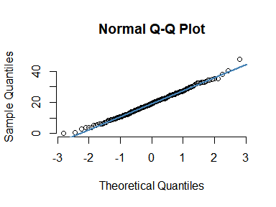

#qqplot(d.body.train$BodyFat)

## b)

Below you have to complete the code and then replace eval=FALSE by eval=TRUE in the chunk options:

regfit_fwd = regsubsets(BodyFat ~ . - Abdomen + poly(Abdomen, degree = 2), data = d.body.train, nvmax = 14, method = "forward")  
regfit_fwd_summary <- summary(regfit_fwd)  
regfit_fwd_summary$outmat

## Age Weight Height Neck Chest Hip Thigh Knee Ankle Biceps Forearm  
## 1 ( 1 ) " " " " " " " " " " " " " " " " " " " " " "   
## 2 ( 1 ) " " "*" " " " " " " " " " " " " " " " " " "   
## 3 ( 1 ) " " "*" " " " " " " " " " " " " " " " " " "   
## 4 ( 1 ) " " "*" " " " " " " " " " " " " " " " " " "   
## 5 ( 1 ) " " "*" " " " " " " " " " " " " " " "*" " "   
## 6 ( 1 ) " " "*" " " "*" " " " " " " " " " " "*" " "   
## 7 ( 1 ) "*" "*" " " "*" " " " " " " " " " " "*" " "   
## 8 ( 1 ) "*" "*" " " "*" " " " " " " " " " " "*" "*"   
## 9 ( 1 ) "*" "*" " " "*" "*" " " " " " " " " "*" "*"   
## 10 ( 1 ) "*" "*" "*" "*" "*" " " " " " " " " "*" "*"   
## 11 ( 1 ) "*" "*" "*" "*" "*" "*" " " " " " " "*" "*"   
## 12 ( 1 ) "*" "*" "*" "*" "*" "*" "*" " " " " "*" "*"   
## 13 ( 1 ) "*" "*" "*" "*" "*" "*" "*" " " "*" "*" "*"   
## 14 ( 1 ) "*" "*" "*" "*" "*" "*" "*" "*" "*" "*" "*"   
## Wrist poly(Abdomen, degree = 2)1 poly(Abdomen, degree = 2)2  
## 1 ( 1 ) " " "*" " "   
## 2 ( 1 ) " " "*" " "   
## 3 ( 1 ) "*" "*" " "   
## 4 ( 1 ) "*" "*" "*"   
## 5 ( 1 ) "*" "*" "*"   
## 6 ( 1 ) "*" "*" "*"   
## 7 ( 1 ) "*" "*" "*"   
## 8 ( 1 ) "*" "*" "*"   
## 9 ( 1 ) "*" "*" "*"   
## 10 ( 1 ) "*" "*" "*"   
## 11 ( 1 ) "*" "*" "*"   
## 12 ( 1 ) "*" "*" "*"   
## 13 ( 1 ) "*" "*" "*"   
## 14 ( 1 ) "*" "*" "*"

plot(regfit_fwd_summary$bic, main = "Forward Stepwise Selection", xlab = "Number of Predictors", ylab = "BIC", type = "l")

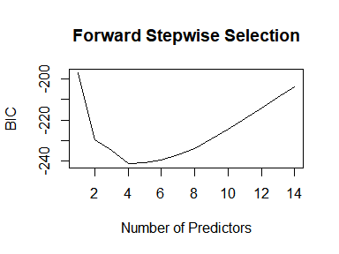

Here we can see that the model with 4 predictors give the lowest BIC. That is model 6 with predictors Weight, Neck, Biceps and Wrist.

best_model <- lm(BodyFat ~ Weight + Neck + Biceps + Wrist, d.body.train)  
  
mse.best_model = mean((d.body.test$BodyFat - predict(best_model, newdata = d.body.test))^2)  
mse.best_model

## [1] 40.89131

The MSE is $40.89131$ with the reduced model

## c)

x.train <- model.matrix(BodyFat ~ . - Abdomen + poly(Abdomen, degree = 2), data = d.body.train)[, -1]  
y.train <- d.body.train$BodyFat  
x.test = model.matrix(BodyFat ~ . - Abdomen + poly(Abdomen, degree = 2), data = d.body.test)[, -1]  
y.test = d.body.test$BodyFat  
  
set.seed(4268)  
cv.lasso <- cv.glmnet(x.train, y.train, alpha = 1)  
plot(cv.lasso)

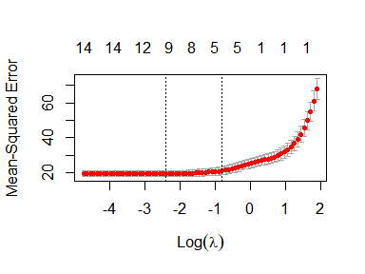

cv.lasso$lambda.1se

## [1] 0.4455843

bodyfat.lasso <- glmnet(x.train, y.train, alpha = 1, lambda = cv.lasso$lambda.1se)  
coef(bodyfat.lasso)

## 15 x 1 sparse Matrix of class "dgCMatrix"  
## s0  
## (Intercept) 47.09872944  
## Age 0.04167346  
## Weight .   
## Height -0.12282724  
## Neck .   
## Chest .   
## Hip .   
## Thigh .   
## Knee .   
## Ankle .   
## Biceps .   
## Forearm .   
## Wrist -1.14587023  
## poly(Abdomen, degree = 2)1 95.63871126  
## poly(Abdomen, degree = 2)2 -11.14529896

mse.lasso = mean((y.test - predict(bodyfat.lasso, newx = x.test))^2)  
mse.lasso

## [1] 50.31623

The MSE for Lasso is $50.31623$.

cv.lasso$lambda.min

## [1] 0.09163496

bodyfat.lasso.min <- glmnet(x.train, y.train, alpha = 1, lambda = cv.lasso$lambda.min)  
coef(bodyfat.lasso.min)

## 15 x 1 sparse Matrix of class "dgCMatrix"  
## s0  
## (Intercept) 69.29797647  
## Age 0.07085015  
## Weight .   
## Height -0.11547703  
## Neck -0.42359496  
## Chest .   
## Hip .   
## Thigh .   
## Knee -0.08296349  
## Ankle .   
## Biceps 0.17064055  
## Forearm 0.20158403  
## Wrist -2.02171921  
## poly(Abdomen, degree = 2)1 112.32782320  
## poly(Abdomen, degree = 2)2 -14.66393600

mse.lasso.min = mean((y.test - predict(bodyfat.lasso.min, newx = x.test))^2)  
mse.lasso.min

## [1] 74.07258

The MSE when $λ_{min}$ is used is much larger than when $λ_{1se}$ is used, thus the model with $λ_{min}$ is not useful.

## d)

#Had problems running this in markdown but it worked in rscript  
# pca.train <- prcomp(d.body.train[, c(2:6,8:-1)] + poly(d.body.train[, c(7)], degree = 2), scale = TRUE)  
# var_explained = pca.train$sdev^2 / sum(pca.train$sdev^2)  
  
# screeplot(pca.train, npcs = min(13, length(pca.train$sdev)), type = c("lines"))

See that the first PC explain over 60% of variability, and PC 2-4 explain approximately 10%, and the rest go near 0. So a useful number would be 5 PCs.

pcr_fit = pcr(BodyFat ~ . - Abdomen + poly(Abdomen, degree = 2), data = d.body.train, scale = TRUE, validation = "CV")  
summary(pcr_fit)

## Data: X dimension: 201 14   
## Y dimension: 201 1  
## Fit method: svdpc  
## Number of components considered: 14  
##   
## VALIDATION: RMSEP  
## Cross-validated using 10 random segments.  
## (Intercept) 1 comps 2 comps 3 comps 4 comps 5 comps 6 comps  
## CV 8.285 6.671 5.698 5.632 5.538 5.324 5.704  
## adjCV 8.285 6.665 5.656 5.628 5.519 5.371 5.667  
## 7 comps 8 comps 9 comps 10 comps 11 comps 12 comps 13 comps  
## CV 5.509 5.102 4.954 4.914 4.875 5.021 4.558  
## adjCV 5.463 5.054 4.926 4.889 4.851 4.985 4.525  
## 14 comps  
## CV 4.476  
## adjCV 4.451  
##   
## TRAINING: % variance explained  
## 1 comps 2 comps 3 comps 4 comps 5 comps 6 comps 7 comps 8 comps  
## X 56.69 66.41 75.17 81.79 86.37 90.61 92.83 94.91  
## BodyFat 36.12 54.98 55.53 58.39 58.40 62.92 66.50 69.40  
## 9 comps 10 comps 11 comps 12 comps 13 comps 14 comps  
## X 96.67 98.00 98.96 99.50 99.84 100.00  
## BodyFat 69.87 70.18 70.70 71.38 75.53 75.59

validationplot(pcr_fit, val.type = "MSEP")

